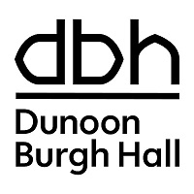 CHRISTMAS ART & CRAFTS EXHIBITION 2025

PLEASE COMPLETE THE FOLLOWING:

Name: _______________________________________________________________________

Address: _____________________________________________________________________

____________________________________________________________________________

Telephone: _________________________________ Mobile: __________________________

Email: _______________________________________________________________________

Please tick if you don’t wish to receive information about future events happening at DBH.

Please give details of the artwork you are submitting (maximum 3 pieces).
Please note – we cannot guarantee that all work will be hung or displayed.

 | TITLE OF WORK | MEDIUM | SELLING PRICE
1
2
3

I agree to paying 30% commission plus VAT to Dunoon Burgh Hall Trust on any sale of
artwork displayed in the Dunoon Burgh Hall Christmas Art & Crafts Exhibition 2025.

I am registered to pay VAT and will invoice Dunoon Burgh Hall Trust accordingly for any sales.

Artist Name: _____________________________________________

Signed: ________________________________________________

COLLECTION OF UNSOLD ARTWORK - Please select:
Monday 22nd December 2025, 11am – 3.00pm
Tuesday 23rd December 2025, 11am – 3.00 pm

